

API Security Risk Analysis Report

CYBERSECURITY TASK #3
ZAMEER HASSAN
June 2026

Table of Contents

1. Executive Summary 2
2. Objectives 3
3. Scope & Ethics 3
4. Methodology 3
5. Tools Used 4
6. API Overview 4
7. Security Findings 5
7.1 Excessive Data Exposure 5
7.2 No Authentication Required 6
7.3 Broken Object Level Authorization (BOLA) 7
7.4 No Rate Limiting 8
7.5 Sensitive Data Exposure 9
7.6 Unauthorized Data Modification 10
7.7 Insecure Direct Object Reference (IDOR) 11
7.8 Missing Security Headers 12
8. Risk Assessment Summary 14
8.1 Summary Table 14
8.2 Overall Risk Rating 14
8.3 Risk Distribution 15
9. Recommendations 15
9.1 Implement Authentication on All Endpoints 15
9.2 Enforce Object-Level Access Controls 15
9.3 Apply the Principle of Data Minimisation 16
9.4 Implement Rate Limiting 16
9.5 Add Missing Security Headers 16
9.6 Priority Order Summary 16
10. Conclusion 16
References 17

1. Executive Summary

This report is a result of a structured API security risk analysis of the JSONPlaceholder public REST API (https://jsonplaceholder.typicode.com), a popular fake REST API that is free and publicly accessible for security test and prototype development. It was carried out through a strictly non-intrusive, observational approach, all tests were done using Postman and Browser DevTools, and it was done as part of the Future Interns Cyber Security Internship program.
Eight individual security vulnerabilities were discovered in four main risk areas: authentication and access control, data exposure, rate limiting, and security misconfiguration. Four findings were given the Critical rating, three were rated as High and one was rated as Medium, giving an overall Critical risk rating for the API if it could be replicated in a production environment.
The worst cases were focused on the lack of authentication on all endpoints, so that anyone with access to the internet could read, write and refer to any resource in the system without restriction. This was worsened by the lack of object-level controls, in that any user's data could be accessed by changing an ID value in the request URI, which is listed as the No. 1 risk in the OWASP API Security Top 10. Further investigations revealed that the API provides too much sensitive personal information, such as GPS information and complete physical addresses, without any filtering mechanism, does not provide any rate-limiting to prevent automated abuse and does not include any important security headers for the HTTP protocol protocol on any response.
This report recommends the most pressing remediation steps to be authentication and object-level access controls, data minimisation, rate limiting enforcement, and security header configuration. All of these measures combined would mitigate all 8 of the vulnerabilities identified and provide a secure base line based on the OWASP API Security Top 10 standards.
This assessment shows that the most prevalent API attacks occur due to the lack of basic security measures that every API that processes user data should have. The results and techniques presented in this report are a real-world account of what API security analysts typically do to find and fix insecure APIs, and how the process can be methodically applied to other APIs in the wild.

2. Objectives

The goal of this report is to do a structured security analysis of a public REST API and look for typical weaknesses and their potential effect on data privacy, system integrity, and application security. This report is to help identify insecure API endpoints that expose sensitive user data without any form of authentication or authorisation check and missing security mechanisms like rate limiting, input validation, and access control enforcement. Assessments of each identified vulnerability are made according to the severity of the vulnerability based on likelihood of exploitation and/or potential business impact, referring to the OWASP API Security Top 10 framework where applicable. Results are backed with actual Request/Response data gathered with Postman and includes clear actionable recommendations for remediation, to present to a development team or security stakeholder.

3. Scope & Ethics

This assessment was used only for the free and publicly available fake REST API, JSON Placeholder (https://jsonplaceholder.typicode.com), which was created and kept by the developers and is intended solely for testing and prototyping. The purpose of JSON Placeholder is to mimic the real API behaviour and it is deliberately provided for developers, learners and researchers who want to learn more about security and researchers. No private, production or proprietary API was used or attacked in any way throughout this evaluation. All testing in this report was passive and observational in nature only. The Postman was used to send only publicly documented HTTP requests of GET and POST types. No attempt at exploitation, brute force attack, denial of service attempt or any active intrusion was made. The information contained in this report is solely based on what the API is doing in response to normal and legal requests, and is only meant to show the common security issues of the API in an educational environment.

This evaluation was conducted during the Cyber Security Internship program for Future Interns. No real user data, live systems or production environments were involved in this analysis and no information is presented here for purposes of awareness or for learning about or learning how to.

4. Methodology

This assessment was conducted using a manual, structured API security testing methodology following OWASP API Security Top 10. First, the documentation for the JSON Placeholder API had to be understood to know what endpoints are available and what the expected structure of the responses is, so that there was a starting point for the tests. Then Postman was used to send HTTP GET and POST requests to several endpoints and for each one of the responses, the level of data exposure, authentication missing, and access control consistency were examined. Browser DevTools has been used to view the HTTP response headers returned by the API and to check if any critical security configurations are missing. Flaws found in the API were documented and assigned a risk level of either ‘Medium', ‘High' or ‘Critical' depending on the probability of the flaw being exploited and the impact it would have on the confidentiality, integrity and availability of the data and system. All results were compared to The OWASP API Security Top 10 list to give industry context.

5. Tools Used

For this evaluation, Postman was the main tool used, allowing structured HTTP GET and POST requests to be made to the JSON Placeholder API to get detailed responses and examine them in detail. Performance and security headers were inspected from the HTTP response headers that were returned from the API using Browser DevTools, and critical security headers were found missing: Content-Security-Policy, X-Frame-Options, X-Content-Type-Options, and Strict-Transport-Security. During the analysis phase, the OWASP API Security Top 10 framework was used to categorize and provide context for each vulnerability identified in relation to industry standards. All findings in this report were documented in a Microsoft Word document.

6. API Overview

Typicode's JSON Placeholder API is a free, open and publicly available REST API that was developed and maintained by typicode and was chosen for this security assessment. It can be accessed at https and can be used by developers, students, and security researchers for testing, prototyping and learning. As its name suggests, JSON Placeholder is a mock REST API that delivers a collection of fake users, posts, comments, albums, photos, and Todo's, all in standard JSON format.
The API accepts all common HTTP methods (GET, POST, PUT, PATCH, and DELETE), and returns realistic data structures that are as close to those of a production application as possible. It does not need any API key, registration, or authentication whatsoever to access and is therefore a perfect choice to safely and legally show common API security weaknesses.
In this assessment, we tested two main resource endpoints: users endpoint /users and posts endpoint /posts. These endpoints were chosen to be the most widely used, and the most sensitive, data types used in real world APIs, such as names, email addresses, physical addresses, phone numbers, and GPS coordinates.

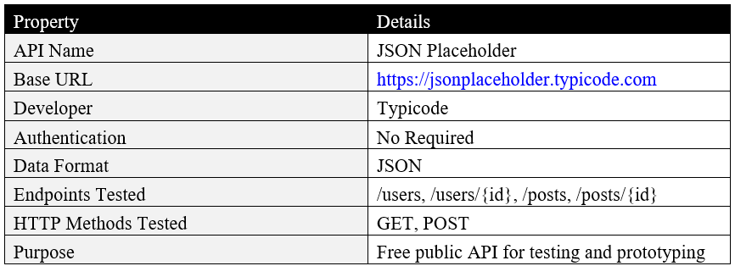

7. Security Findings

This section provides the 8 security findings that we found during the assessment of the JSONPlaceholder API. Every finding contains a description of the vulnerability, supporting evidence, risk severity and business impact.

7.1 Excessive Data Exposure

Risk Level: High
OWASP API Top 10 Category: API3:2023 - Broken Object Property Level Authorization

Description
A typical GET service on /users returns additional information for all users within the system such as full name, username, email, complete physical address, GPS coordinates, phone number, website and detailed company information. This information is returned in one request without any filter or restriction and not authenticated.

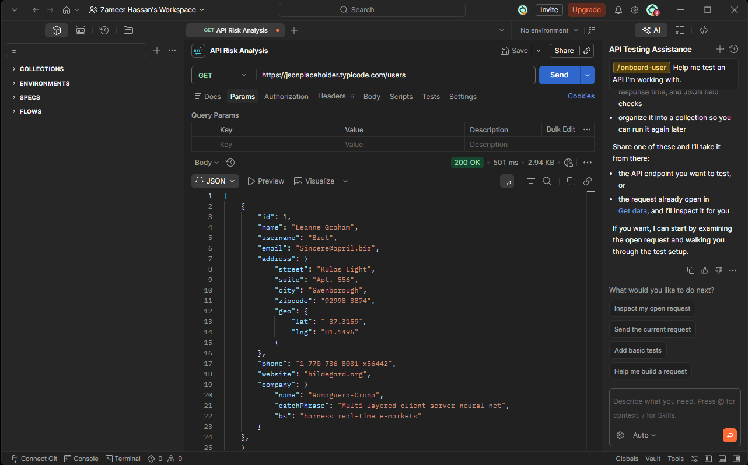
Figure 1: GET request to /users endpoint returning complete user profiles including personal and location data

Business Impact
If this was an actual case, this amount of personal information in a single answer would make any data breach that much more impactful. In a production environment an attacker would be able to get all personal information of all registered users in one go, which would make it possible to steal their personal identities, send targeted phishing emails, or profile all users of the production system.

Recommendation
The principle of data minimisation should be applied to APIs, only returning the fields necessary for the use case. Certain types of data, like GPS coordinates, full address, and phone numbers, should only be returned to requests that have been properly authenticated and authorized, and preferably only to the user of the radio or the authorized administrator.

7.2 No Authentication Required

Risk Level: Critical
OWASP API Top 10 Category: API2:2023 - Broken Authentication

Description
It was verified that no API key, bearer token, session cookie or any other means of authentication was needed to have access to any of the endpoints when visiting the Authorization tab in Postman for all of the requests tested. All requests, such as sensitive personal information, were processed and returned with a successful response with no ID checks.

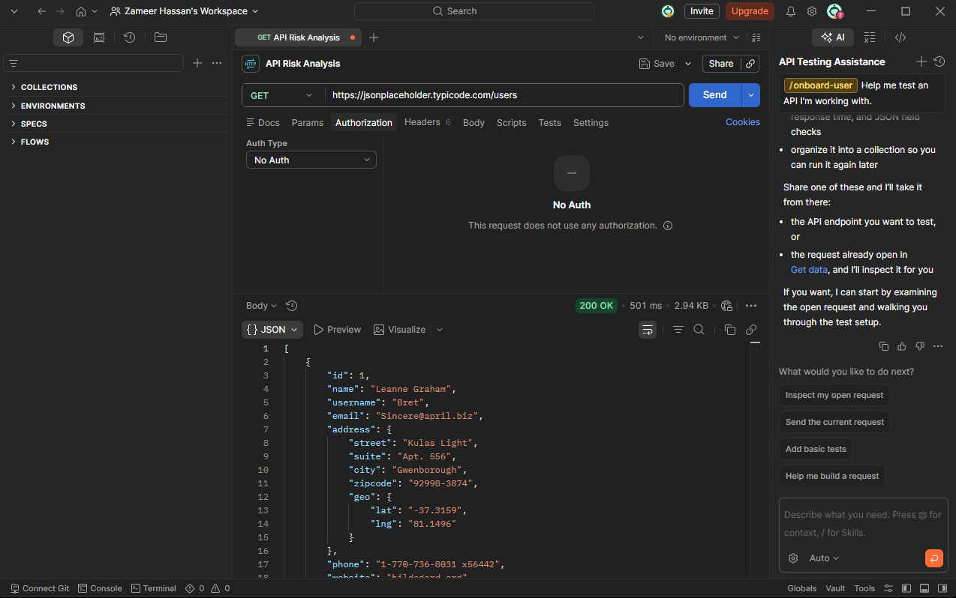
Figure 2: Postman Authorization tab confirming "No Auth" is required to access the API

Business Impact
No authentication means that anyone with access to the internet can unrestrictedly query the API and get sensitive data from it, including malicious users. This is a serious security lapse in a production environment where no control, tracking, or limiting of user data access would be possible. It makes data scraping, unauthorized data harvesting possible and opens the door to all sorts of other attacks that require unrestricted access.

Recommendation
All API endpoints, especially those that return personal or sensitive information, should be secured with authentication via industry-standard methods [OAuth 2.0, API keys, or JSON Web Tokens (JWT)]. If the request is not accompanied by a valid authentication credential, it shall be denied access without processing any information. A request that does not contain authentication credentials shall be denied access without processing any information.

7.3 Broken Object Level Authorization (BOLA)

Risk Level: Critical
OWASP API Top 10 Category: API1:2023 - Broken Object Level Authorization

Description
It was possible to get the full profile of any user in the system without any authorisation check by simply changing the value in the user ID section of the request URL. A GET call on /users/1 returned the entire profile for user 1 and a GET call on /users/5 returned the entire profile for a different user with no indication of any right for the requesting party to access that user's information.

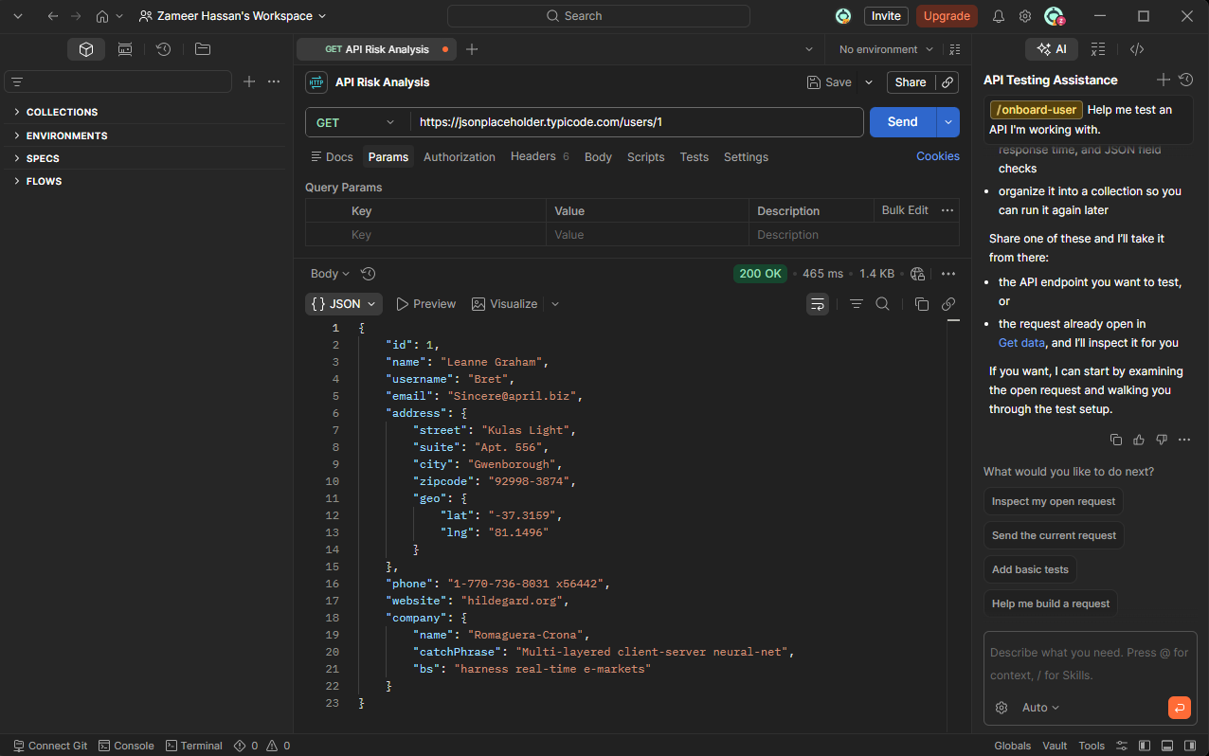
Figure 3: GET request to /users/1 returning full profile of user 1

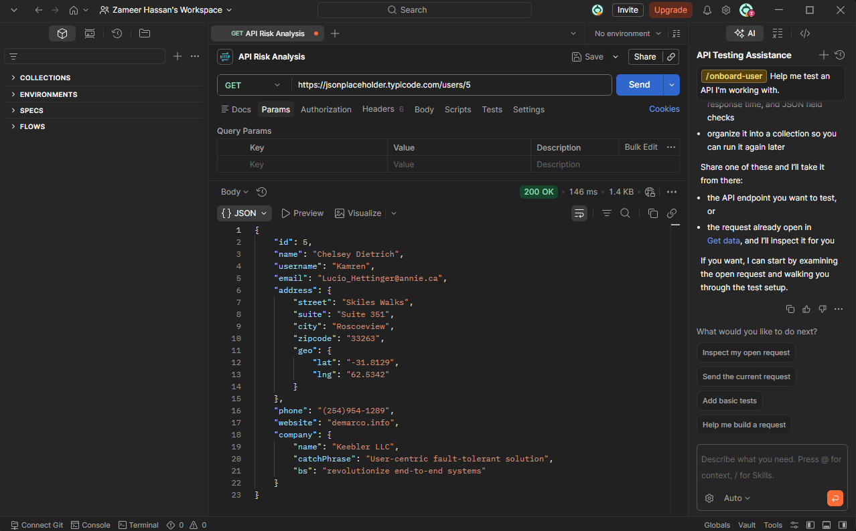
Figure 4: GET request to /users/5 returning full profile of user 5 - demonstrating unrestricted access by simply changing the ID

Business Impact
As with the OWASP Top 10, Broken Object Level Authorization is a serious and common flaw in real-world applications, and is the #1 vulnerability in the OWASP API Security Top 10. This flaw would present an opportunity for any user to view private information of any other user in a production setting by just adding or guessing an ID number. This is every user's privacy is totally compromised, data protection laws like GDPR are broken and may put an organisation in huge trouble.

Recommendation
For any given API call, each user (that is, the client) should check whether he or she has explicit permission to access a specific object. If the requesting user is not the owner or has not been authorised to access the requested resource, then the API should return a 403 Forbidden response. Object IDs should never be the only method used to control access – ownership and permission checks must be performed at the server level for each request.

7.4 No Rate Limiting

Risk Level: High
OWASP API Top 10 Category: API4:2023 - Unrestricted Resource Consumption

Description
The /users endpoint was called repeatedly over a short period of time during the testing. In all cases the API responded with 200 OK without any slowdown or throttling or block at any time. The API did not impose any limits on the number of calls that can be made within any time interval, thus allowing for potentially unlimited calls to be made without any repercussions.

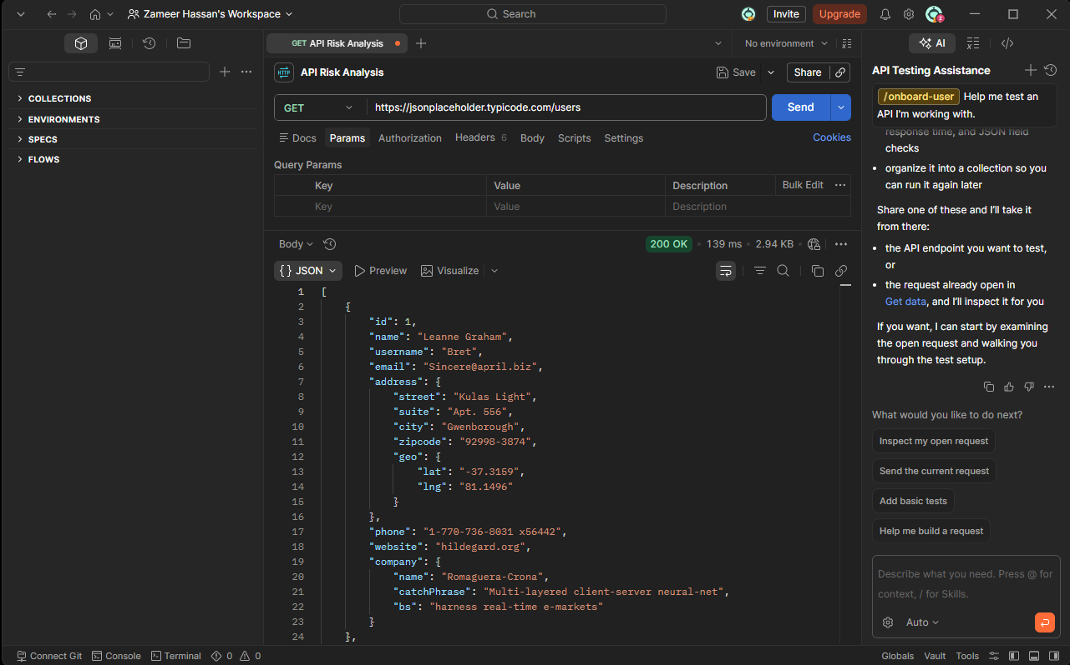
Figure 5: Repeated GET requests to /users endpoint all returning 200 OK with no throttling or blocking applied

Business Impact
Rate limiting is missing, opening the API to a number of potential vulnerabilities. An attacker would be able to automatically process thousands of requests per second to get all the user information in seconds. If no rate limiting is applied, it's easier for the attackers to use brute force attacks, which involve trying combinations of passwords one by one until the right one is finally discovered. Moreover, large amounts of automated requests may overload the server leading to poor performance or even to denial of service to legitimate users.

Recommendation
All API endpoints should have a rate limit, which limits the number of requests that a single client can make within a specified period of time. If a request exceeds the limit, it should be served with a message of "Too Many Requests" (429). More restrictions and account lockout systems should be used for sensitive endpoints like login and password reset. You can also automatically identify and block unusual patterns of requests with a Web Application Firewall (WAF) or API gateway.

7.5 Sensitive Data Exposure

Risk Level: High
OWASP API Top 10 Category: API3:2023 - Broken Object Property Level Authorization

Description
When I tried to execute the GET request on /users/1, it was found that a lot of sensitive data is being returned for each user in a single response. In addition to basic information like name and email, the response provided a user's full physical street address, city, zipcode, GPS location (latitude/longitude), phone number and detailed company information such as internal business phrases. What is most notable is that the full physical address plus a pinpointed GPS location in one un-authenticated response is a significant privacy concern.

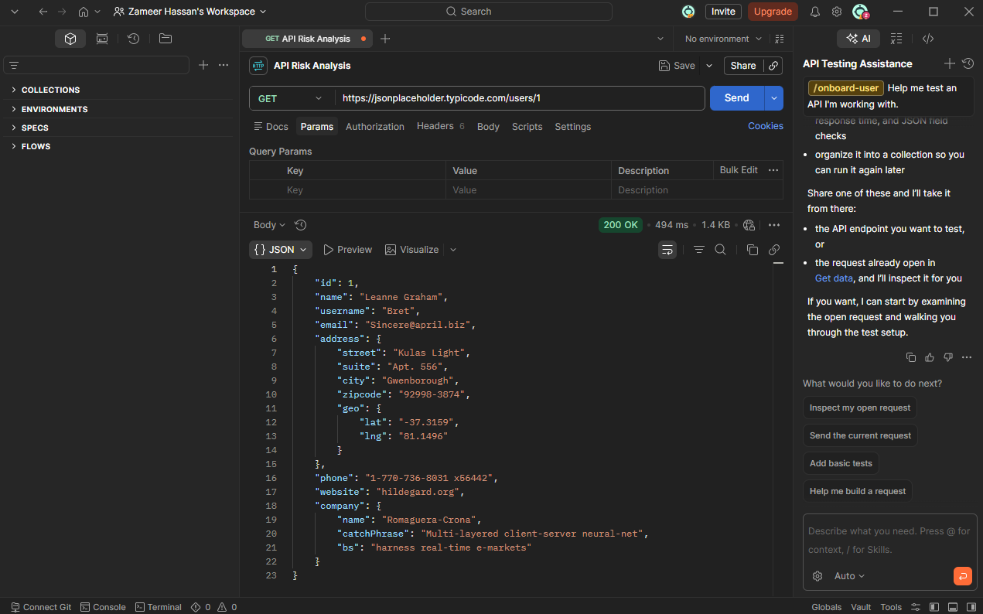
Figure 6: GET request to /users/1 returning sensitive personal data including physical address, GPS coordinates, and phone number

Business Impact
The inclusion of complete physical addresses with GPS coordinates could allow for real world physical harm in a production, as it could be possible to use GPS information to physically find and track a person without that person's knowledge and consent. Overall, the amount of information delivered by a single non-authenticated request opens up a huge compliance risk for organizations under data protection laws, like GDPR and CCPA, that mandate that organizations only collect and release the necessary personal data. One such breach could lead to significant penalties, potential lawsuits and even permanent damage to the organization’s reputation.

Recommendation
The principle of data minimization is a key guideline that APIs must follow, meaning that only the necessary fields are returned in the response. For sensitive information like GPS coordinates, complete physical addresses and phone numbers, these should not be included in the API response by default, but only provided to the user by an authenticated and authorized request. This should be enforced on a per-request basis by having field level access controls at the API level.

7.6 Unauthorized Data Modification

Risk Level: Critical
OWASP API Top 10 Category: API2:2023 - Broken Authentication

Description
It makes a POST request to the /posts endpoint with a bogus JSON body, but no authentication whatsoever. The API accepted the request and returned a 201 Created response, which means that the data was successfully created on the server. This shows how anyone can write data to the API without any identity verification and authorization check.

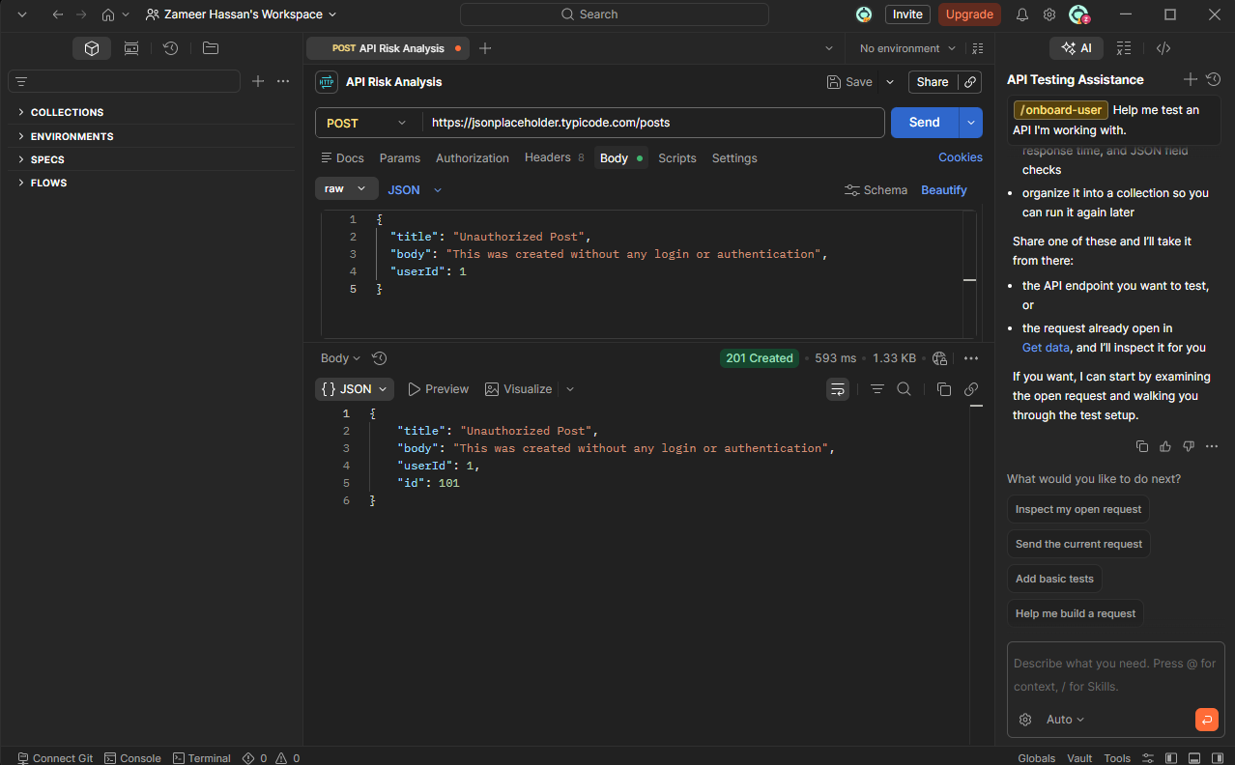
Figure 7: POST request to /posts endpoint successfully creating new data without any authentication — response returns 201 Created

Business Impact
If you can create or update or add data without authentication, you have a serious integrity issue in a production environment. An attacker might be able to enter false or malicious information into the system, alter existing data, or enter bogus information into the system, making the program unreliable or unusable. In the financial, healthcare, or legal sectors, such as, unauthorised data alteration may lead to serious repercussions in the real world, such as fraud, misdiagnosis, or legal liability. This flaw also allows denial of service attacks, as the bots could go round and round the clock writing junk data into the system, effectively making it a denial-of-service attack on the database.

Recommendation
Any write request (POST, PUT, PATCH, DETELE) must be properly authenticated by the user. The API should check the identity of the requester and ensure that they are authorised to create or update the requested resource. If no authentication information has been provided, they should be denied with a 401 Unauthorized response. All data being received must be validated to ensure that the data that is received is not malformed or malicious in any way.

7.7 Insecure Direct Object Reference (IDOR)

Risk Level: Critical
OWASP API Top 10 Category: API1:2023 - Broken Object Level Authorization

Description
It was possible to specify a post ID that you could directly access any post resource in the system without any checks of ownership or permission for that post. The requests were sent to /posts/1, /posts/50 and /posts/100, each of which returned the entire content of different posts from different users. There are no rights to access the requested post and no authentication exists so the API didn't check whether the requester had any right to access the requested post or whether the post belonged to the authenticated person.

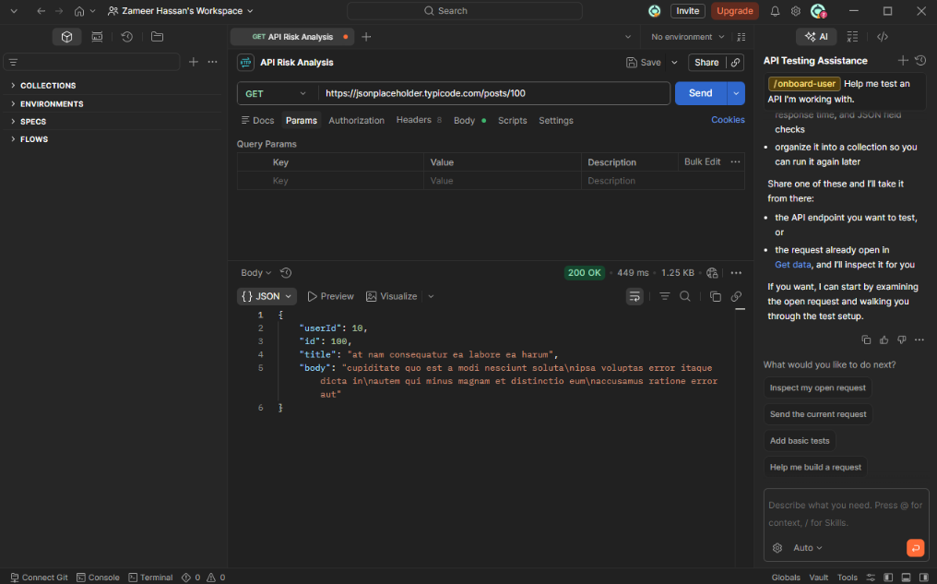
Figure 8: GET request to /posts/100 demonstrating unrestricted access to any post resource by manipulating the ID value in the URL

Business Impact
One of the most frequent vulnerabilities that are exploited in real-world APIs or web apps is Insecure Direct Object Reference. If the post, record or document is owned by a specific user, then any attacker could read or modify the private content of any other user by incrementing or guessing an ID number. With applications that process sensitive data like private conversations, healthcare records, financial information, and legal documents, it could lead to serious data leaks, legal infractions, and substantial damage to users' information. This API employs sequential, predictable IDs which an attacker could easily use to enumerate all the resources.

Recommendation
Access should not be denied to any given resource because of only a valid resource ID, but rather due to who the user is and their explicit access level. For each request the API must check whether the user accessing the object wants the right to access the specific object requested, and return a 403 Forbidden response if the user does not have the right. To minimize potential for automated enumeration attacks, non-sequential or randomly-generated resource identifiers, such as UUIDs, should be used instead of predictable integer IDs where possible.

7.8 Missing Security Headers

Risk Level: Medium
OWASP API Top 10 Category: API8:2023 - Security Misconfiguration

Description
When a request is sent to the JSONPlaceholder API, this is what is returned in the HTTP response headers that are returned in response to the request: Browser DevTools' HTTP response headers were used to check for the presence of a few of the security headers that are considered standard practice in any secure web or API development: The API response lacked the following headers:

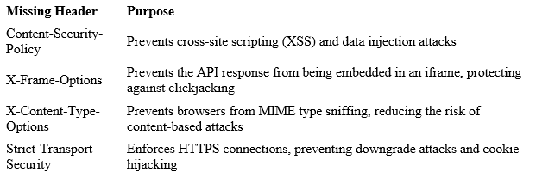

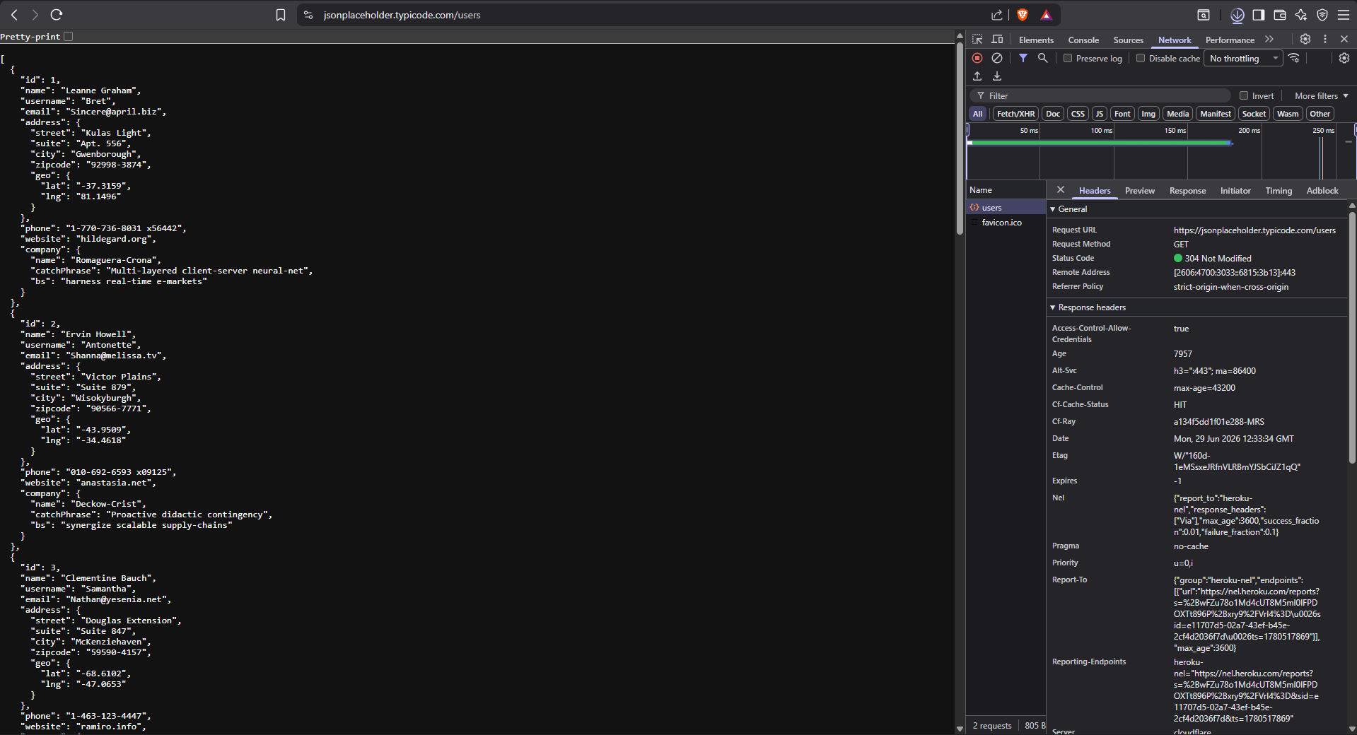
Figure 9: Browser DevTools response headers for JSONPlaceholder API - critical security headers are absent from the response

Business Impact
Without these security headers, both the API and the clients using it are susceptible to various attacks from clients. If no Content-Security-Policy is specified, the application is susceptible to a Cross Site Scripting Attack that may allow malicious scripts to be injected and run in a user's browser. The absence of X-Frame-Options header means that the API responses can be included in malicious iframes so that clickjacking could be used to direct users to perform unauthorized actions. If no Strict-Transport-Security is being used, then a network-level attacker could downgrade the connection from HTTPS to HTTP, allowing the attacker to intercept all data that is sent. Each of these headers is a medium level threat but the absence of all of these headers greatly expands the attack surface of the application.

Recommendation
The recommended security headers should be supplied as a minimum configuration in all API responses. These headers should be applied at the server level or API gateway level to be consistently enforced at all endpoints. Security headers should be scanned and fixed automatically, and should be part of the development pipeline to identify and fix missing headers before they enter production.

8. Risk Assessment Summary

This section summarizes the eight vulnerabilities found in the assessment and their risk levels and potential impact on a realistic application.

8.1 Summary Table

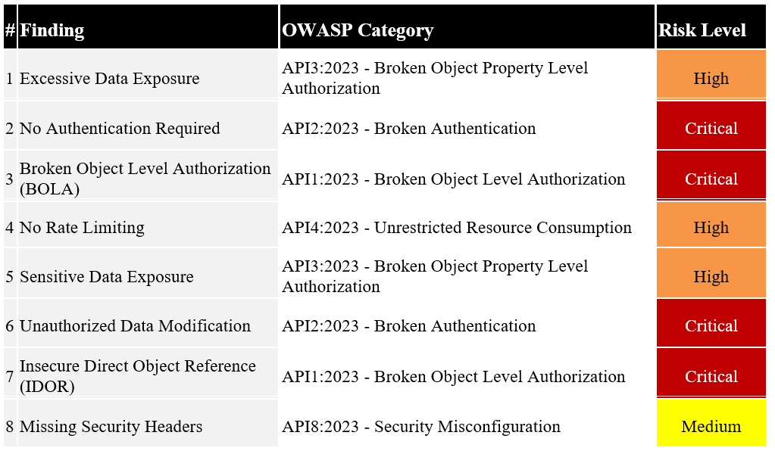

8.2 Overall Risk Rating

Based on the findings identified in this assessment, the JSONPlaceholder API presents a Critical overall security risk if its behaviour were replicated in a production environment. Four of the eight findings were classified as Critical, three as High, and one as Medium. The concentration of Critical findings around authentication and access control represents the most significant area of concern, as these two categories form the foundational security layer of any API. Without authentication and proper object-level access controls, all other security measures become ineffective since there is no verified identity layer upon which to enforce them.

8.3 Risk Distribution

The eight findings can be grouped into three core security weakness categories that together represent the primary risk profile of this API:
The most severe risk area is Authentication and Access Control, encompassing findings 2, 3, 6, and 7. The complete absence of authentication combined with unrestricted object-level access means that any actor can read, create, or reference any resource in the system without restriction. This category alone is sufficient to classify the API as critically insecure in a production context.

The second risk area is Data Exposure, covering findings 1 and 5. The API consistently returns more data than necessary, including highly sensitive personal information such as GPS coordinates and full physical addresses, without any filtering or fiel d-level access control. This compounds the authentication failures by ensuring that any unauthorised access immediately yields maximum personal data.

The third risk area is Infrastructure and Configuration, covering findings 4 and 8. The absence of rate limiting and security headers represents a failure at the server configuration level rather than the application logic level. While individually less severe than the authentication failures, these weaknesses significantly expand the range of attacks available to a malicious actor and reduce the API's resilience against automated abuse.

9. Recommendations

Based on the eight vulnerabilities identified in this assessment, the following recommendations are proposed to improve the security posture of the API. These are organised by priority, addressing the most critical weaknesses first.

9.1 Implement Authentication on All Endpoints

The most urgent remediation required is the implementation of a robust authentication mechanism across all API endpoints. No endpoint, whether read-only or write-enabled, should be accessible without a verified identity. Industry-standard authentication protocols such as OAuth 2.0 or JSON Web Tokens (JWT) should be adopted, requiring all clients to present a valid token with every request. Requests without valid credentials should be immediately rejected with a 401 Unauthorized response before any data processing occurs. This single change would directly address findings 2 and 6 and would significantly reduce the exploitability of findings 3 and 7.

9.2 Enforce Object-Level Access Controls

Every request targeting a specific resource must include a server-side verification step confirming that the authenticated user has explicit permission to access that particular object. It is not sufficient to verify that a user is authenticated - the API must also verify that they are authorised to access the specific resource being requested. Requests where the authenticated user does not own or have permission to access the target resource should return a 403 Forbidden response. Non-sequential, randomly generated identifiers such as UUIDs should replace predictable integer IDs wherever possible to reduce the risk of automated enumeration. This directly addresses findings 3 and 7.

9.3 Apply the Principle of Data Minimisation

API responses should be reviewed and restructured to return only the fields strictly necessary for the requested operation. Sensitive fields such as GPS coordinates, full physical addresses, phone numbers, and internal company data should be excluded from general listing endpoints and restricted to authenticated, owner-level requests only. Field-level access controls should be enforced at the API layer to ensure that different user roles receive only the data appropriate to their permission level. This directly addresses findings 1 and 5.

9.4 Implement Rate Limiting

Rate limiting should be enforced on all API endpoints to restrict the number of requests a single client can send within a defined time window. Clients exceeding the limit should receive a 429 Too Many Requests response. Stricter limits should be applied to sensitive operations such as login, password reset, and data creation endpoints. An API gateway or Web Application Firewall (WAF) should be considered to automatically detect and block abnormal traffic patterns before they reach the application layer. This directly addresses finding 4.

9.5 Add Missing Security Headers

All API responses should include the full recommended set of HTTP security headers as a baseline configuration. At a minimum, the following headers should be added to every response: Content-Security-Policy, X-Frame-Options, X-Content-Type-Options, and Strict-Transport-Security. These headers should be applied at the server or API gateway level to ensure consistent enforcement across all endpoints without requiring changes to individual endpoint logic. Automated security header scanning should be incorporated into the development and deployment pipeline to detect regressions before they reach production. This directly addresses finding 8.

9.6 Priority Order Summary

Among all recommendations, implementing authentication is the highest priority as it is the foundational control upon which all other security measures depend. Object-level access controls should follow immediately, as they prevent the most commonly exploited category of API vulnerability. Data minimisation, rate limiting, and security header implementation should then be addressed in parallel as part of a broader secure development baseline.

10. Conclusion

This report has presented a structured security assessment of the JSONPlaceholder public REST API, identifying eight vulnerabilities across four core security categories: authentication and access control, data exposure, rate limiting, and security misconfiguration. The assessment was conducted using a strictly non-intrusive, observational methodology, with all findings based entirely on the API's response to standard, legitimate HTTP requests.
The results of this assessment highlight a recurring theme that is well-documented across the API security industry: the most damaging vulnerabilities are rarely the result of sophisticated technical exploits, but rather the absence of fundamental security controls. The complete lack of authentication, the absence of object-level access controls, and the unrestricted exposure of sensitive personal data represent failures at the foundational design level rather than at the implementation level. These are not edge cases or obscure attack vectors - they are the first checks any security professional would perform against a live API, and they are the categories most frequently exploited in real-world data breaches.
It is important to note that JSONPlaceholder is intentionally designed as an open, unauthenticated API for testing and prototyping purposes, and the vulnerabilities identified in this report are expected and inherent to its design. The purpose of this assessment was not to criticise the API itself, but to use its behaviour as a realistic demonstration of what insecure API design looks like in practice, and to document what a real-world security analyst would identify and report when assessing an API with similar characteristics.

The findings and recommendations presented in this report reflect the standards set by the OWASP API Security Top 10, which remains the most widely referenced framework for API security risk classification in the industry. Organisations building or maintaining APIs are strongly encouraged to use this framework as a baseline checklist during both the design and testing phases of API development, and to conduct regular security assessments to identify and remediate vulnerabilities before they can be exploited in production.
Ultimately, this assessment reinforces that secure API design requires deliberate, security-first thinking at every stage of development. Authentication, access control, data minimisation, and infrastructure hardening are not optional enhancements - they are the baseline requirements for any API that handles user data in a responsible and trustworthy manner.

References

OWASP. (2023). OWASP API Security Top 10 2023. Retrieved from https://owasp.org/API-Security/editions/2023/en/0x00-header/

typicode. (2024). JSONPlaceholder - Free Fake REST API. Retrieved from https://jsonplaceholder.typicode.com

Postman. (2026). Postman API Platform. Retrieved from https://www.postman.com

Mozilla Developer Network. (2026). HTTP Headers - MDN Web Docs. Retrieved from https://developer.mozilla.org/en-US/docs/Web/HTTP/Headers

Mozilla Developer Network. (2026). HTTP Response Status Codes - MDN Web Docs. Retrieved from https://developer.mozilla.org/en-US/docs/Web/HTTP/Status

OWASP. (2023). OWASP Top 10 API Security Risks - Broken Object Level Authorization. Retrieved from https://owasp.org/API-Security/editions/2023/en/0xa1-broken-object-level-authorization/

Cloudflare. (2026). What is Rate Limiting? Retrieved from https://www.cloudflare.com/learning/bots/what-is-rate-limiting/

Future Interns. (2026). Cyber Security Task 3 - API Security Risk Analysis Guidelines.

